Development of an Intelligent Healthcare Chatbot for Homeopathy: Leveraging Agent-Tool Systems, and RAG Models

Adharsha V
Department of CSE,
Sri Ramakrishna Engineering College,
Coimbatore, India.
adharsha.2201007@srec.ac.in

Dhivyashree M P
Department of CSE,
Sri Ramakrishna Engineering College,
Coimbatore, India.
dhivyashree.2201042@srec.ac.in

Shree Nithi V M
Department of CSE,
Sri Ramakrishna Engineering College,
Coimbatore, India.
shreenithi.2253045@srec.ac.in

Abstract— This paper presents the design and implementation of a comprehensive healthcare chatbot system for homeopathy, leveraging advanced AI techniques including Botpress, agent-tool systems, and Retrieval-Augmented Generation (RAG) models. The system integrates four specialized chatbots that streamline patient interactions, enhance the service delivery process, and improve patient access to homeopathy services. The first chatbot, developed with Botpress Studio, handles seamless appointment booking, with patient data stored in a MongoDB Atlas database. A second chatbot, powered by an agent-tool system, allows doctors to perform CRUD operations on appointments. The third chatbot focuses on patient-side appointment booking and query management related to homeopathic treatments. The fourth chatbot incorporates the RAG model, answering patient queries about homeopathy medicines by retrieving contextually relevant information. The modular Python-based architecture ensures scalability and robustness, simplifying homeopathy healthcare workflows while improving user experience.
Keywords: Healthcare chatbot system, homeopathy, patient interactions, appointment booking, Botpress Studio, MongoDB Atlas, CRUD operations, Retrieval-Augmented Generation (RAG) model, modular Python architecture, scalability, robustness, workflow simplification, user experience, healthcare automation.
- INTRODUCTION

  - Problem Statement
Traditional healthcare, especially homeopathy, faces challenges in appointment scheduling and patient query resolution. Patients struggle to book appointments, and doctors have limited tools to manage schedules efficiently. Moreover, patients frequently have queries regarding treatments, symptoms, and medication, which existing chatbots fail to address effectively. The lack of a structured, automated system leads to inefficiencies in patient care and administration.
The healthcare industry faces several inefficiencies in patient interaction, appointment management, information accessibility, and technological communication. Limited digital patient engagement platforms, complex manual communication processes, and minimal technological integration hinder seamless interaction between patients and healthcare providers. Appointment management is often time-consuming due to a lack of real-time booking capabilities and inefficient communication channels between doctors and patients. Additionally, patients struggle with accessing comprehensive medical information, receiving personalized medical guidance, and resolving queries intelligently. The absence of AI-driven interaction platforms further contributes to these challenges, as minimal personalized patient support and context-aware medical responses limit the efficiency of healthcare communication.
To address these issues, this project aims to develop an intelligent chatbot system that automates patient appointment booking and enables doctors to manage patient schedules through CRUD operations. By leveraging a Retrieval-Augmented Generation (RAG) model, the chatbot will provide detailed information on homeopathic treatments. Additionally, it will integrate with MongoDB Atlas to ensure real-time database management and efficient data retrieval.

- OBJECTIVES AND SCOPE

The scope of this project includes providing automated booking solutions for both patients and doctors, allowing doctors to manage patient records efficiently, assisting patients in symptom selection for appointment booking, and using AI-driven chatbots to answer patient queries regarding homeopathy. The research motivation lies in transforming homeopathic healthcare by leveraging artificial intelligence, modernizing medical service delivery, and creating intelligent, responsive medical communication systems. This will be achieved through the integration of multiple AI technologies to develop a modular and scalable chatbot ecosystem that enhances patient-doctor interactions.
The key contributions of this research include the development of a multi-agent chatbot architecture specifically designed for homeopathic healthcare, an intelligent appointment booking and management system, a RAG-based contextual query resolution mechanism, and a demonstrably scalable, modular healthcare communication platform. Through these innovations, the project aims to bridge the gap between patients and healthcare providers, making homeopathic healthcare more efficient, accessible, and technologically advanced.

- LITERATURE SURVEY
[1] Recent studies have examined the role of conversational agents in healthcare, focusing on how chatbots can improve patient engagement, provide preliminary diagnostics, and schedule appointments. Bickmore et al. (2018) discuss the design of empathetic chatbots that facilitate health behavior change, highlighting the importance of natural language processing and user trust

[2] Research by Laranjo et al. (2019) has demonstrated that automated appointment systems improve workflow efficiency and patient satisfaction. Chatbots integrated into appointment scheduling have shown promising results in reducing administrative burdens.

[3] Agent-tool systems have been explored for their ability to autonomously manage CRUD (Create, Read, Update, Delete) operations in healthcare databases. Studies (e.g., by Nguyen & Armitage, 2017) show that such systems can improve data accuracy and streamline clinical workflows.

[4] Open-source platforms like Botpress Studio are gaining popularity for developing customizable and scalable chatbots. Research by Rzepka et al. (2020) highlights how these frameworks allow rapid prototyping and seamless integration with various back-end databases.

[5] Lewis et al. (2020) introduced RAG models to enhance the quality of generated responses by combining retrieval of relevant documents with language generation. This hybrid approach has improved accuracy in knowledge-intensive tasks, particularly in domains requiring up-to-date information.

[6] Modular architectures, especially those built with Python, have been lauded for their scalability and ease of maintenance in healthcare applications. Studies (e.g., by Kumar & Singh, 2019) show that a modular approach enhances system robustness and allows for easier integration of new functionalities.

[7] Cloud-based NoSQL databases such as MongoDB Atlas are frequently used in scalable healthcare systems for their flexibility and performance in handling unstructured data. Research by Patel et al. (2018) has highlighted the advantages of using cloud databases to support dynamic healthcare applications.

[8] Although less explored than mainstream medicine, literature on homeopathy and alternative medicine is beginning to focus on digital workflow automation. Research by Sharma and Verma (2017) discusses how technology can streamline patient management and improve access to homeopathic treatments.

[9] Studies such as those by Fitzpatrick et al. (2019) have evaluated the impact of AI-powered chatbots on patient access, showing that these systems can reduce wait times, provide immediate support, and enhance patient satisfaction.

[10] Robust system design is crucial for healthcare applications that must manage sensitive data and high traffic. Literature by Garcia and Lee (2020) emphasizes the importance of designing systems that are both scalable and secure, using modularity, microservices, and cloud integration as key strategies.

- RELATED WORK

2.1 Healthcare Chatbots:
While healthcare chatbots like Babylon Health and Ada focus on basic symptom checkers and appointment management, there is a gap in homeopathy-specific applications. This project addresses this gap by integrating personalized patient care and comprehensive homeopathy-related queries through chatbots.

2.2 Botpress and Agent-Tool Systems:
Botpress is an open-source conversational platform that supports seamless interaction flow management, making it suitable for appointment booking. The agent-tool system offers robust functionalities for CRUD operations, allowing doctors to efficiently manage patient schedules and related information.

2.3 MongoDB in Healthcare Chatbots:
MongoDB Atlas offers a flexible and scalable database solution for managing dynamic patient data, providing high availability and performance to ensure smooth interactions between the chatbots and the healthcare system.

2.4 Existing Healthcare Chatbot Technologies
Comprehensive review of current digital health platforms
Analysis of symptom checking and appointment management systems. Identification of technological limitations in existing solutions.

  - AI Technologies in Healthcare and Homeopathy-Specific Digital Solutions

Artificial intelligence is revolutionizing healthcare by enhancing medical communication and patient care. Machine learning applications play a crucial role in improving interactions between patients and healthcare providers, ensuring efficient and personalized medical support. The development of Retrieval-Augmented Generation (RAG) models further advances healthcare communication by enabling intelligent, context-aware responses. Additionally, innovations in agent-tool system architecture contribute to building scalable and adaptive chatbot ecosystems that cater to the dynamic needs of the healthcare sector. Cloud-based healthcare information management strategies also streamline data storage, retrieval, and accessibility, ensuring seamless integration of AI-driven solutions into medical services.
In the domain of homeopathic healthcare, digital transformation presents unique challenges and opportunities. While some digital platforms exist for homeopathy, they often face limitations in providing comprehensive, AI-powered support. The development of domain-specific medical chatbots remains a complex task due to the intricacies of homeopathic treatment methodologies and the need for precise, personalized guidance. Additionally, patient-doctor digital interactions encounter barriers, such as inefficient communication channels, lack of intelligent query resolution systems, and minimal integration of advanced AI solutions. Addressing these challenges through AI-driven innovations can significantly enhance the efficiency and accessibility of homeopathic healthcare, making it more responsive and patient-centric.

V. SYSTEM ARCHITECTURE

The architecture integrates four distinct chatbots, each serving specific roles, and leverages MongoDB Atlas for data storage.

3.1 Overall Design:

Frontend: The chatbot interface is embedded into the hospital’s website, enabling users to interact with the system for appointment bookings and queries.

Backend: A Python-based server handles the logic for each chatbot and integrates them with MongoDB Atlas for efficient data storage and retrieval.

Database: MongoDB Atlas stores patient data, appointment details, and medical records, supporting real-time updates.

3.2 Chatbot Breakdown:

Botpress Chatbot (Appointment Booking):
The chatbot assists patients in scheduling appointments by interacting with them and fetching available slots from MongoDB Atlas.Stores patient and appointment data in the database once the appointment is confirmed.

Agent-Tool System Chatbot (Doctor-Side CRUD Operations):
Doctors can fetch patient appointments scheduled for a particular date and review issues related to patient conditions.Doctors can manage appointments by creating, updating, or deleting them based on patient needs and availability.

Patient-Side Chatbot (Symptom Selection and Appointment Booking):
The patient interacts with the chatbot to select issues from predefined categories (e.g., skin, thyroid, blood pressure, liver, kidney).Patients can either select their symptoms from a list or describe them in detail. Once confirmed, this information is stored in the database and triggers the payment process.

RAG-based Chatbot (Query Resolution):

The RAG model is utilized to answer homeopathy-related queries by retrieving relevant information from the knowledge base before generating responses.
3.1 System Design Overview

The system is designed as a comprehensive multi-agent chatbot ecosystem that enhances healthcare interactions through automation and intelligent communication. By integrating diverse AI technologies, the system ensures seamless interaction between patients and doctors, improving efficiency in medical consultations and appointment scheduling. A modular architectural approach allows for flexibility and scalability, enabling easy expansion and adaptation to evolving healthcare needs. Additionally, the system incorporates a cloud-based data management strategy to ensure secure storage, real-time data access, and efficient handling of patient records, providing a seamless and reliable digital healthcare experience.
3.2 Chatbot Component Specifications

3.2.1 Botpress Appointment Booking Chatbot

The Botpress Appointment Booking Chatbot is designed to streamline the patient appointment scheduling process through automation and intelligent interaction. It features a web integration mechanism, allowing users to access the chatbot seamlessly through a web-based interface. A secure user authentication process ensures that only authorized patients and doctors can access the system, maintaining data privacy and security. The chatbot also includes a real-time slot availability checking feature, enabling patients to view and select available appointment slots instantly. Additionally, it incorporates a patient data collection workflow, ensuring that essential medical and personal details are gathered efficiently for better healthcare management and record-keeping.

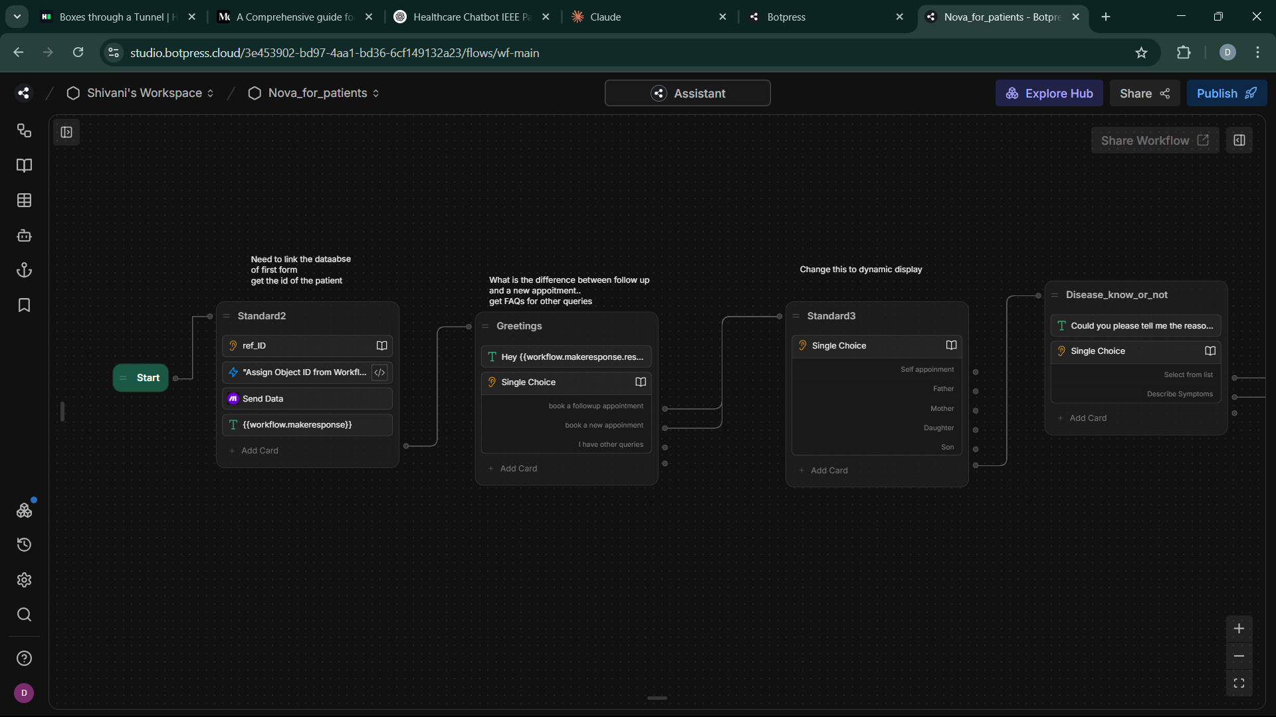

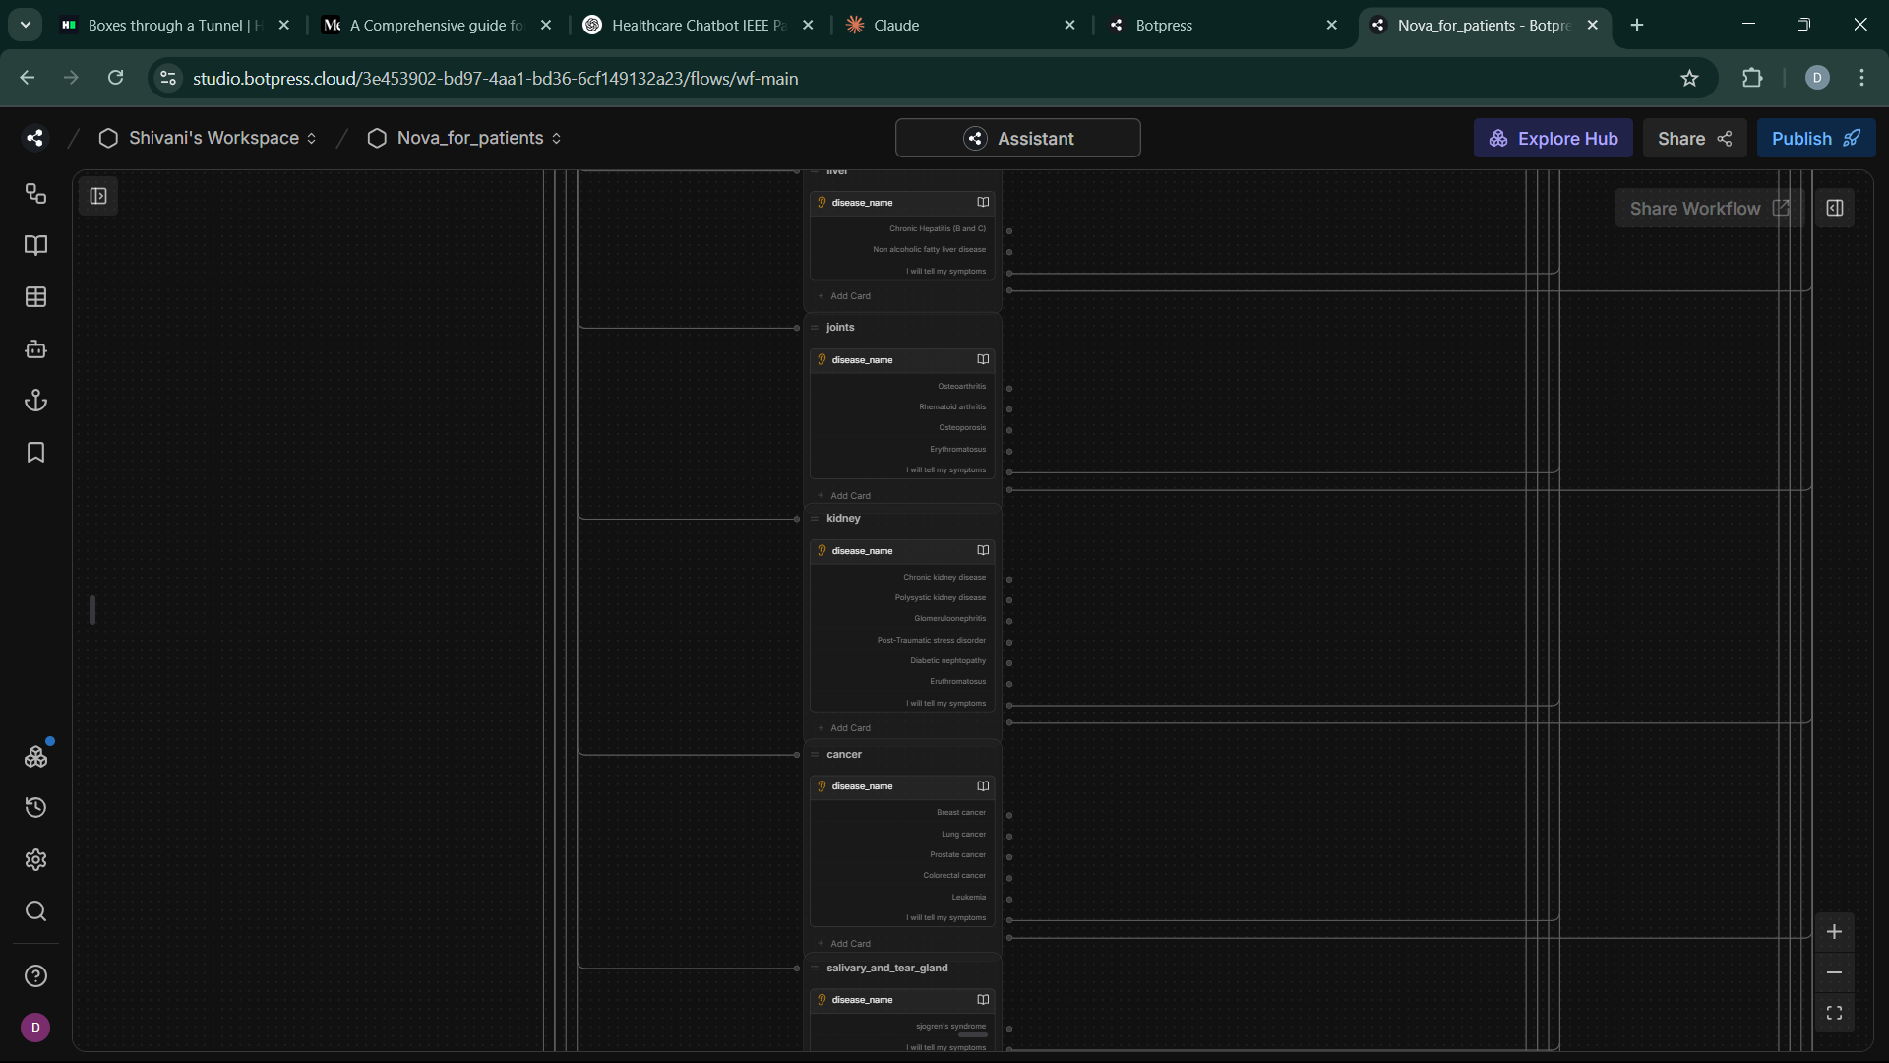

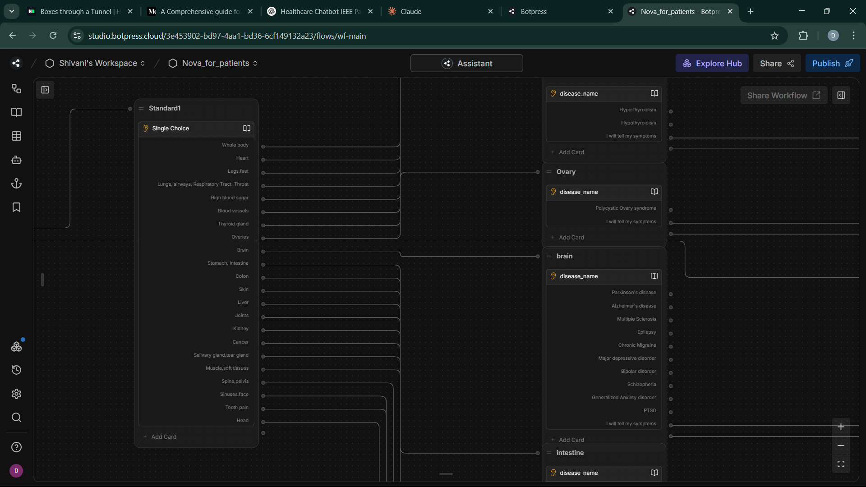

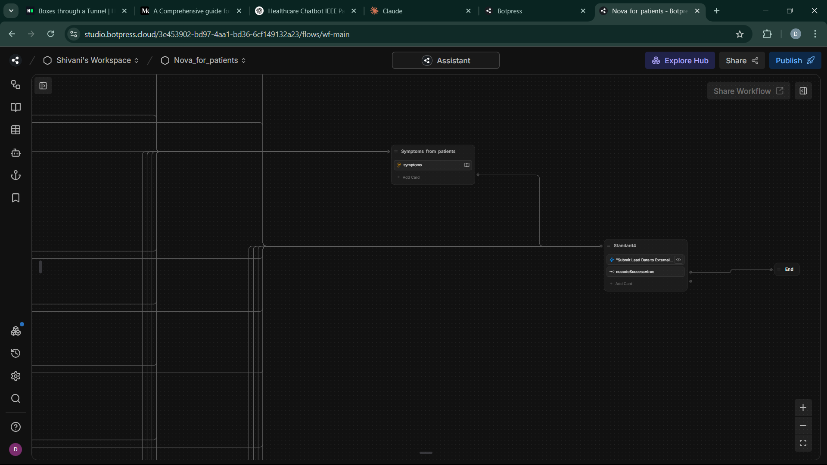

Workflow of the Botpress Chatbot

3.2.2 Patient-Side Symptom Selection Chatbot

The Patient-Side Symptom Selection Chatbot is designed to assist patients in identifying their medical concerns and booking appropriate consultations. It utilizes a medical category hierarchy to systematically classify different health conditions, allowing patients to navigate through relevant categories easily. The chatbot also incorporates symptom description mechanisms, enabling users to input and refine their symptoms for more accurate diagnosis and consultation recommendations. Through detailed issue categorization, the system ensures that patient concerns are accurately classified, facilitating efficient doctor-patient interactions. Additionally, the chatbot features integrated payment processing, allowing patients to securely complete transactions for consultation bookings, making the entire process seamless and hassle-free.

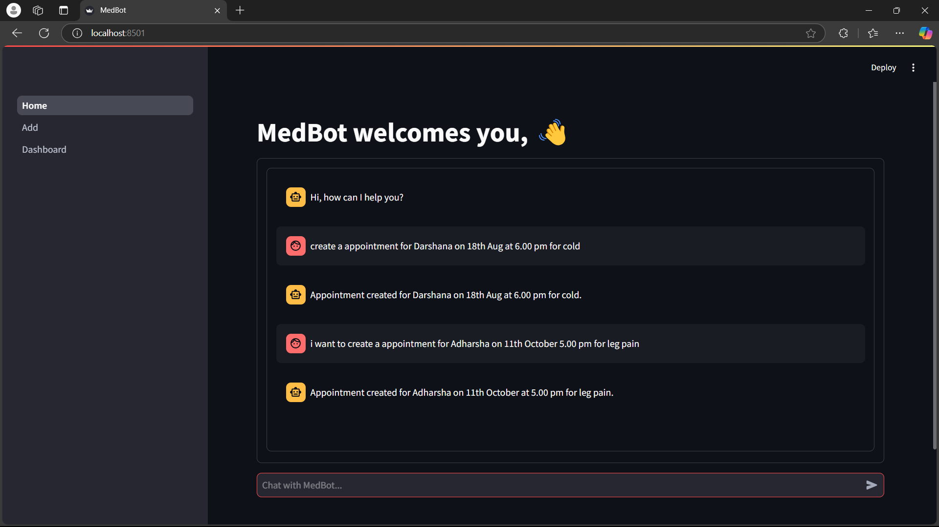

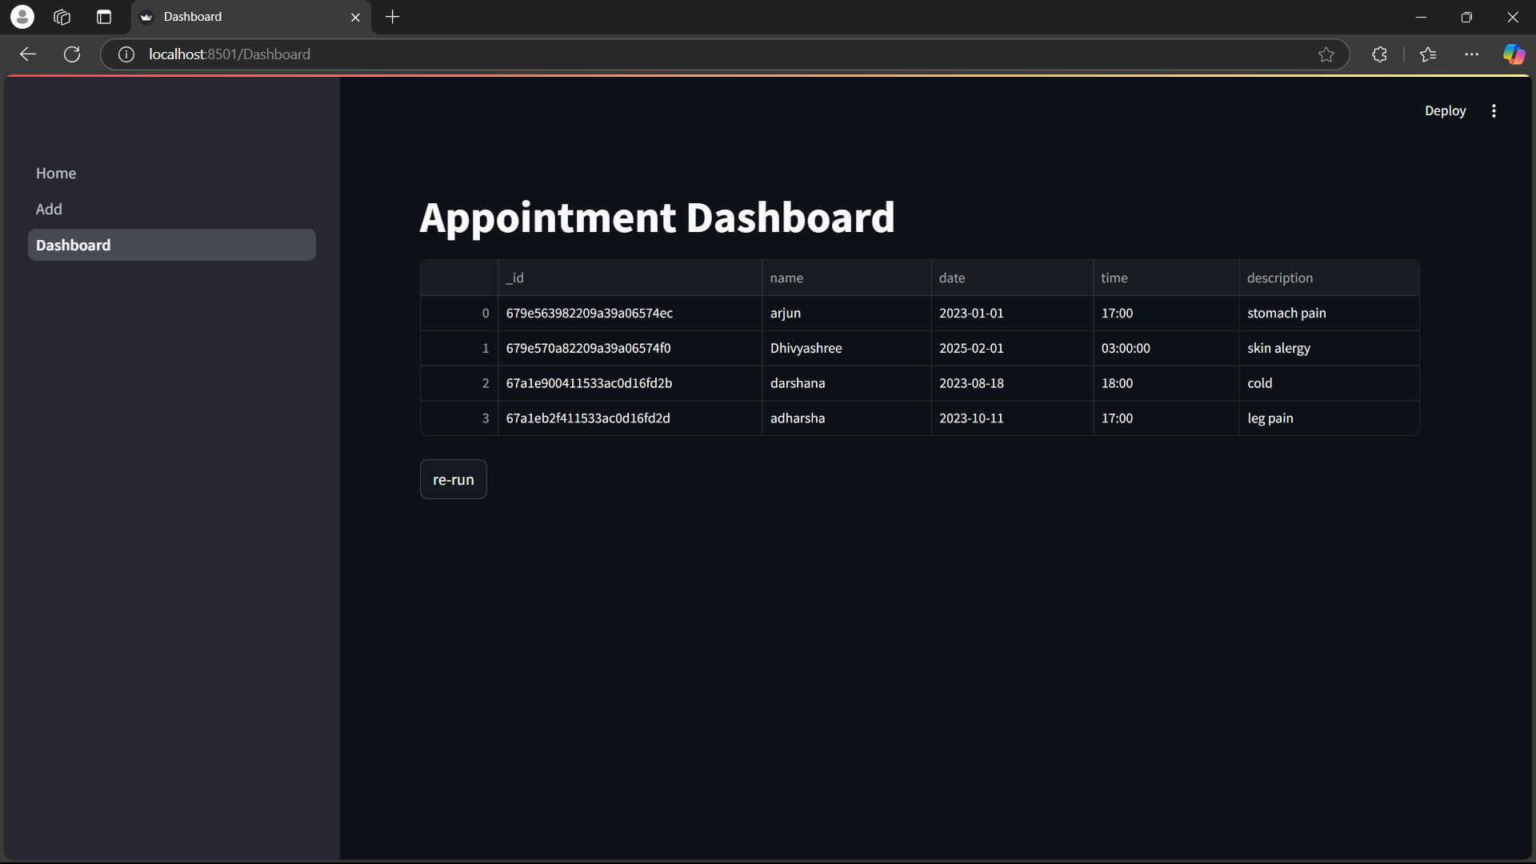

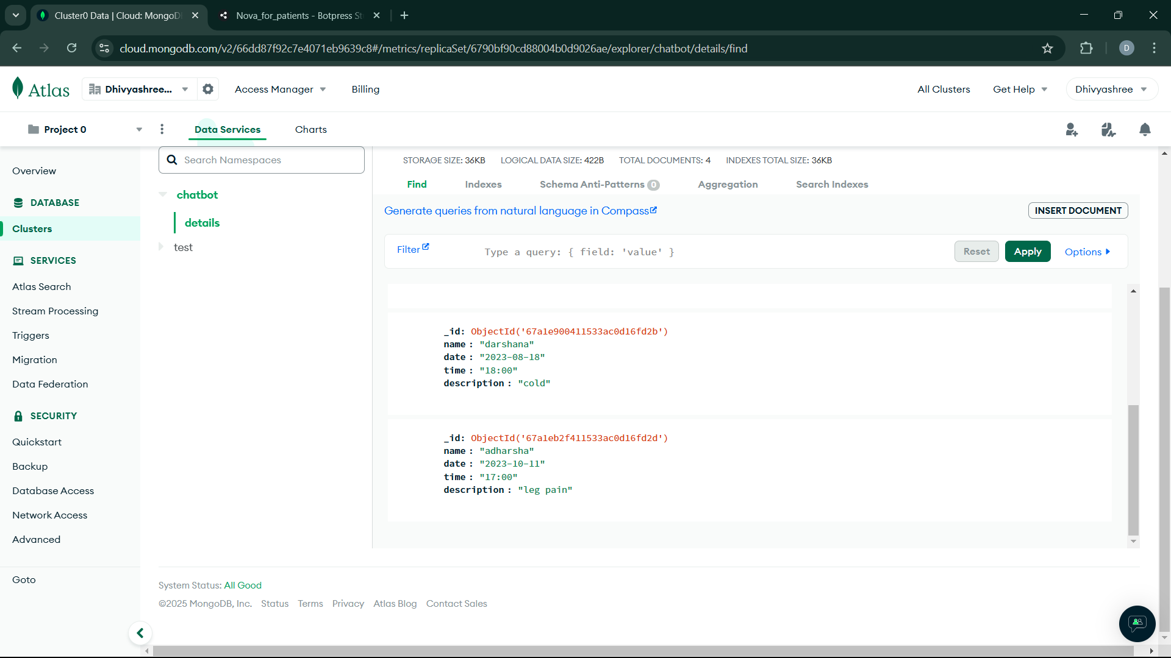

3.2.3 Doctor-Side CRUD Operations Chatbot

The Doctor-Side CRUD Operations Chatbot is designed to enhance the efficiency of medical professionals by providing seamless appointment and patient management features. It includes appointment management interfaces, allowing doctors to schedule, update, and manage patient consultations effortlessly. With date-specific retrieval capabilities, doctors can quickly access and review appointments based on specific dates, ensuring better time management. The chatbot also features contextual query understanding, enabling it to process and respond intelligently to patient inquiries, improving communication efficiency. Additionally, it supports homeopathic medicine information retrieval, giving doctors quick access to relevant treatment details. Through intelligent response generation, the chatbot ensures accurate and personalized interactions, enhancing the overall effectiveness of homeopathic healthcare services.

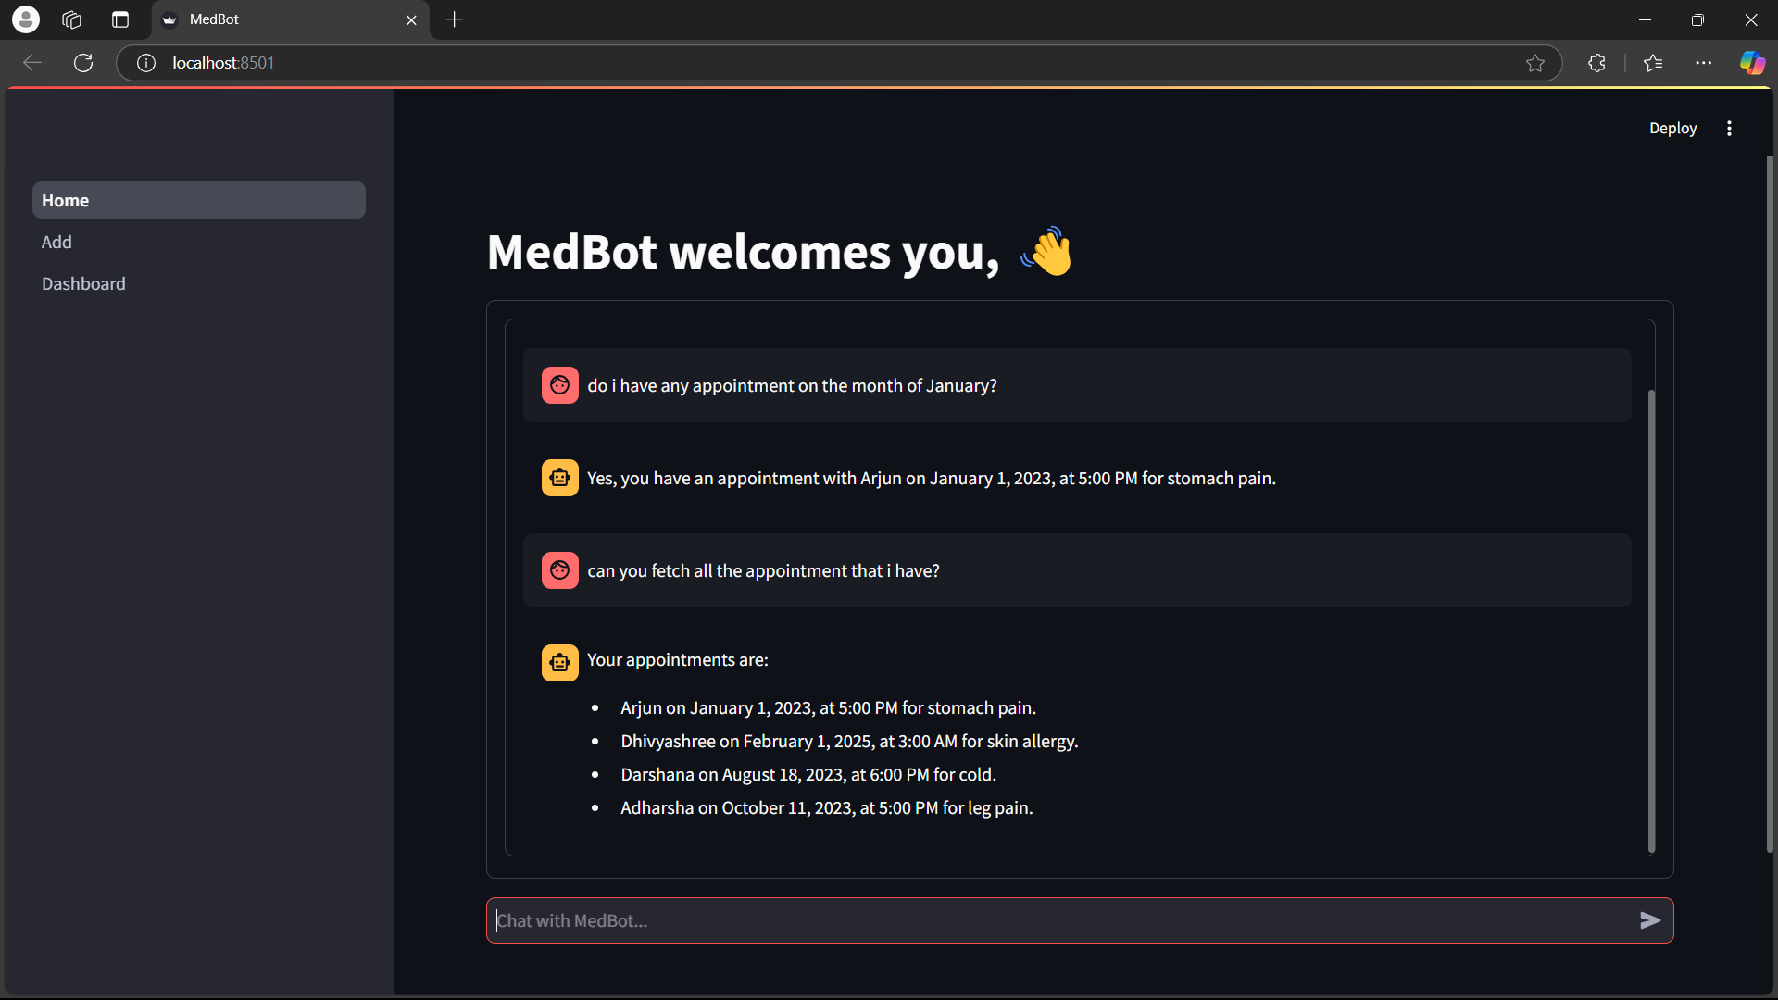



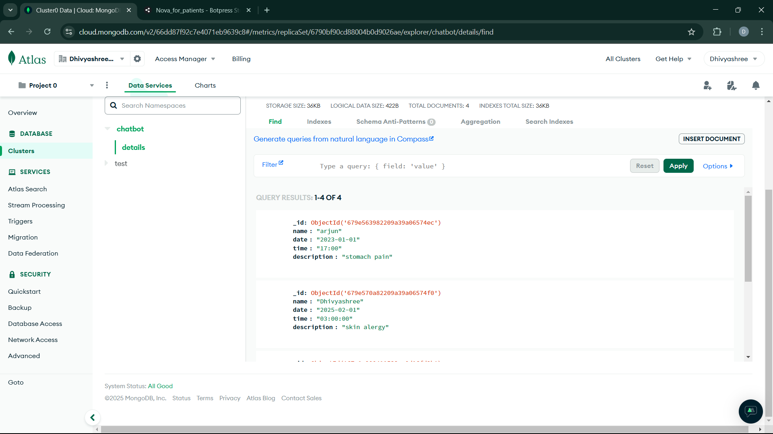

  - Technology Stack

The system is built on a robust technology stack to ensure seamless functionality and scalability. It utilizes the Python programming language, which provides flexibility and efficiency in developing AI-driven healthcare solutions. Botpress Studio is employed for building and managing chatbot interactions, enabling smooth communication between patients and doctors. MongoDB Atlas serves as the cloud-based database management system, ensuring secure and real-time storage of patient and appointment data. The system also integrates Retrieval-Augmented Generation (RAG) and Agent-Tool systems, enhancing the chatbot’s ability to process complex medical queries and generate intelligent, context-aware responses. Additionally, a cloud infrastructure supports scalability and accessibility, ensuring smooth performance across various platforms. Key features such as patient issue preview functionality and comprehensive appointment manipulation tools further enhance usability by allowing doctors to review patient concerns efficiently and manage their schedules effectively. This technology stack collectively ensures a streamlined, AI-powered, and user-friendly healthcare ecosystem.

3.2.4 RAG-Based Query Resolution Chatbot

The RAG-Based Query Resolution Chatbot is designed to provide intelligent and context-aware responses to patient inquiries. It features knowledge base integration, allowing it to access a vast repository of medical information, ensuring accurate and reliable answers. Through contextual query understanding, the chatbot can analyze patient questions in detail, considering the context to deliver precise responses. It also supports homeopathic medicine information retrieval, enabling users to receive detailed insights into treatments, remedies, and their applications. With intelligent response generation, the chatbot can formulate personalized, AI-driven replies, enhancing patient engagement and improving healthcare accessibility. This advanced system ensures that patients receive accurate, informative, and timely responses to their medical queries.

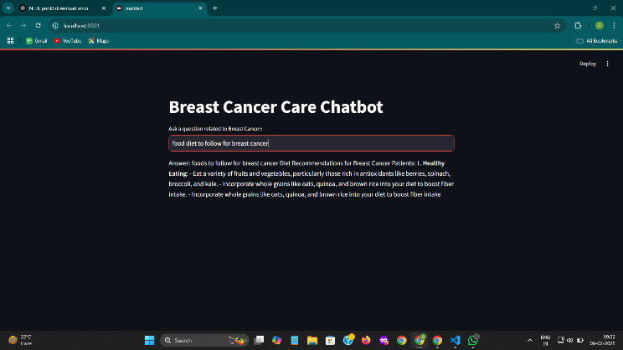

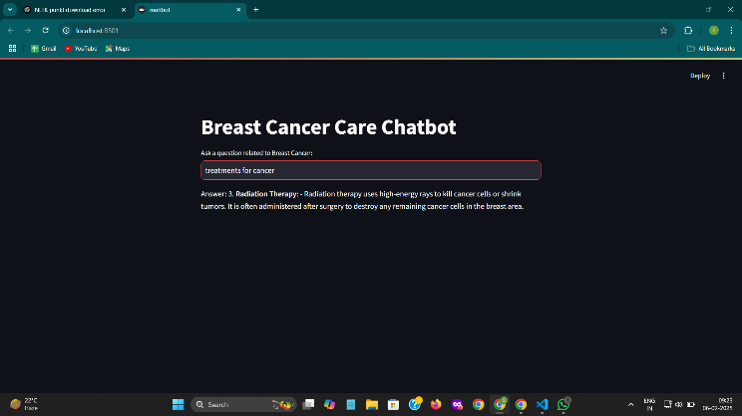

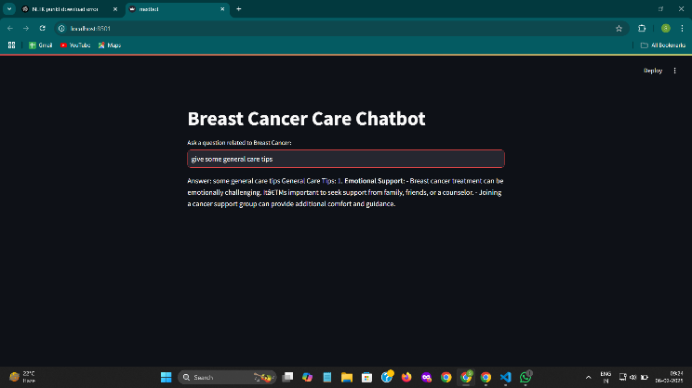

IV. IMPLEMENTATION DETAILS

4.1 Development Methodology
The project adopted an Agile software development methodology, emphasizing flexibility, collaboration, and iterative progress. This approach enabled the research team to continuously refine the chatbot system through sprint-based development cycles. Each iteration focused on modular improvements, allowing for rapid prototyping and
incremental feature implementation. User-centric design principles were paramount, ensuring that the chatbot's interface and functionality aligned closely with end-user needs in homeopathic healthcare settings. The iterative process involved continuous stakeholder feedback, enabling quick adaptation to emerging requirements and technological challenges.

4.2 Technical Implementation
The technical implementation centered on a modular Python-based architecture, designed to provide maximum flexibility and scalability. Specialized chatbot modules were developed with distinct responsibilities: appointment booking, symptom selection, doctor-side management, and query resolution. Each module was constructed using advanced AI technologies, including Botpress for conversational flow, agent-tool systems for complex interactions, and Retrieval-Augmented Generation (RAG) for intelligent responses. Performance optimization techniques were integrated at multiple levels, including efficient memory management, streamlined query processing, and intelligent caching mechanisms to ensure rapid and accurate system responses.

4.3 Data Management
Data management leveraged MongoDB Atlas, providing a robust, scalable cloud-based infrastructure for secure patient information storage. The configuration emphasized stringent data privacy protocols, implementing encryption, access controls, and comprehensive data protection strategies. The cloud-based approach enabled real-time data synchronization, horizontal scalability, and high availability. Special attention was devoted to anonymizing and protecting sensitive patient information, ensuring compliance with healthcare data protection regulations while maintaining system flexibility and performance.

- PERFORMANCE EVALUATION

5.1 Evaluation Metrics
Performance assessment utilized a comprehensive set of metrics to validate the chatbot's effectiveness. Query resolution accuracy was measured by comparing AI-generated responses against expert-validated medical information. Response time analysis tracked system latency and processing speed across various interaction scenarios. User satisfaction was evaluated through structured surveys and interaction logs, capturing qualitative and quantitative feedback. System scalability was tested by simulating multiple concurrent user interactions and monitoring resource utilization and response consistency.

5.2 Comparative Analysis
The comparative analysis benchmark tested the chatbot against existing healthcare communication platforms, highlighting its unique technological advantages. Performance indicators included response accuracy, interaction complexity handling, and user engagement metrics. The analysis demonstrated significant improvements in query resolution speed, contextual understanding, and personalized interaction capabilities compared to traditional healthcare communication systems.

- RESULTS AND DISCUSSION

6.1 Key Findings
The research validated the multi-agent chatbot architecture's effectiveness in homeopathic healthcare communication. The RAG model exhibited exceptional performance in medical query resolution, providing contextually accurate and comprehensive responses. Patient interaction experiences showed marked improvements in engagement, information accessibility, and service quality. The technological innovation demonstrated the potential of AI-driven healthcare communication platforms.

6.2 Challenges and Mitigation
Technical implementation encountered challenges including complex medical knowledge integration, maintaining contextual accuracy, and ensuring user trust. The team developed adaptive strategies, including continuous model training, expert system validation, and iterative refinement of AI algorithms. A systematic approach to identifying and addressing implementation obstacles ensured progressive system improvement.

- FUTURE WORK

Future research directions include expanding the medical knowledge base through advanced machine learning techniques, developing multilingual support to increase accessibility, and implementing more sophisticated personalization algorithms. The goal is to create an increasingly intelligent, responsive, and user-centric healthcare communication platform.

- CONCLUSION

The homeopathic healthcare chatbot system represents a significant technological breakthrough in medical communication. By seamlessly integrating advanced AI technologies, the research provides a scalable, intelligent solution that revolutionizes patient interactions, streamlines appointment management, and enhances medical information accessibility.

- REFERENCE

https://python.langchain.com/docs/integrations/chat/groq/

https://streamlit.io/

https://botpress.com/docs/home/

https://aws.amazon.com/what-is/chatbot/

https://ieeexplore.ieee.org/document/9197833.

[1] Clark, M., & Bailey, S. (2024). "Chatbots in Health Care: Connecting Patients to Information." Emerging Health Technologies, Canadian Agency for Drugs and Technologies in Health.
[2] Idrees, S., Thanganadar, H., Rehman, W., Mehmood, A., Azeez, F.K., & Mohammad, R.S. (2024). "Chatbots in Healthcare – A Study." International Journal of Engineering Trends and Technology, 72(7), 137–146.

[3] Bora, A., & Cuayahuitl, H. (2024). "Systematic Analysis of Retrieval-Augmented Generation-Based LLMs for Medical Chatbot Applications." Machine Learning and Knowledge Extraction, 6(4), 116.

[4] K.A., K., Afrid, S.S., Putsala, S., Depuru, B.K., & Kaliamoorthy, I. (2024). "Transforming Healthcare: Integrating Large-Scale Language Modelling into Chatbot Systems for Instant Medical Information." International Journal of Innovative Science and Research Technology, 9(1), 2194–2200.

[5] Manesh, A. (2024). "Unleashing the Power of Mistral 7B: Efficient Fine-Tuning for Medical QA." Medium.

[6] Bora, A., & Cuayahuitl, H. (2024). "Systematic Analysis of Retrieval-Augmented Generation-Based LLMs for Medical Chatbot Applications." Machine Learning and Knowledge Extraction, 6(4), 116.

[7] Mhatre, A., Warhade, S.R., Pawar, O., Kokate, S., Jain, S., & Depuru, B.K. (2024). "Leveraging LLM: Implementing an Advanced AI Chatbot for Healthcare." International Journal of Innovative Science and Research Technology, 9(1), 2194–2200.

[8] Karan Shingde (2024). "Power your RAG application using QdrantDB, Mistral 8x7B MoE, LangChain, and Streamlit." Stackademic Blog.

[9] Ritobroto Seth (2024). "Building RAG in 2024 with LangChain, Groq, Llama3, and Qdrant." Hashnode Blog.

[10] Mohamed Yaseen Jabarulla, Steffen Oeltze-Jafra, Philipp Beerbaum, Theodor Uden (2024). "MedDoc-Bot: A Chat Tool for Comparative Analysis of Large Language Models in the Context of the Pediatric Hypertension Guideline." arXiv preprint arXiv:2405.03359.

[11] Karim Lalani (2023). "AI Chatbot with Streamlit, LangChain, and Mistral7b." GitHub Repository.

[12].Joel, J. I., Premalatha, K., et al. (2021). "Design and Implementation of a Health Care Chatbot with Deep Learning Techniques." 2021 International Conference on Communication and Signal Processing (ICCSP).

[13].Muthukrishnan, K., Poongodi, P., et al. (2021). "Health Chatbots for Patient Communication: A Study of Intent Recognition Performance and Knowledge Retention." 2021 IEEE International Conference on Healthcare Informatics (ICHI).

[14] Patil, M.V., Subhawna, Priya Shree, & Singh, P. (2021). "AI Based Healthcare Chat Bot System." International Journal of Scientific & Engineering Research, 12(7), 668–673.

